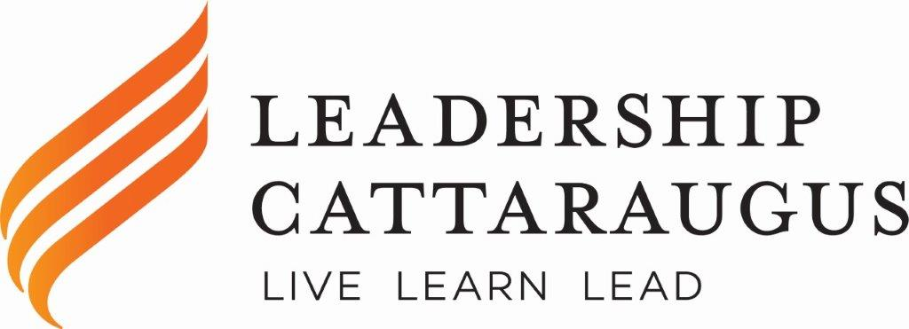
C/O Greater Olean Chamber of Commerce
301 North Union Street Olean, NY 14760
Phone: 376-7572 Fax: 376- 7031
Leadershipcattaraugus.org

(date)

(personalized with name and address)

Thank you so very much for agreeing to speak with the current Leadership Cattaraugus Cohort about the role that your business/organization plays in making our County a vibrant place to live and work! The purpose of this letter is to confirm the date and time of our visit and provide you with contact information in the event that something changes on the day of your presentation. Our program days are filled with many speakers and visits, and so we ask that you notify us if you are unable to join us or are going to be late.

We are currently scheduled to visit your site on:
(Insert date, start and end times)

In addition, we have asked that you:
(Summarize arrangements discussed: provide a tour, discuss ________; participate in a panel discussion on…..)

In addition to the topics discussed when we spoke, we would like to ask that you consider and be prepared to discuss the following topics. These topics speak to your leadership attributes and to your perceptions about challenges you face in your career. We believe that these topics are of interest to our cohort because leadership is multi-faceted and dynamic.

- Please share not only the “nuts and bolts” of your business/organization, but also the leadership skills that are essential to success in your field. What leadership skills do you use on a daily basis to get things done? What skills and resources are required to be the best at what you do?

- Please consider the challenges and benefits of conducting business in Cattaraugus County? Are there unique strengths or challenges to working in Cattaraugus County? What obstacles do you face and how do you overcome them? What resources are available to help and what is still needed?

We hope that this information has been helpful. If this is not consistent with your current understanding, please reach out to us using the contact information shown at the close of this letter. Once again, thank you for presenting to our class and for all that do you to make our County a great place to live!

Respectfully,

Signature
Contact Information

